**Stereochemistry of Alkene Additions: addition of Bromine to *trans-*Cinnamic Acid**

**Introduction**

The main purpose of this lab experiment is to brominate trans-cinnamic acid. This would be done through a reflux process, then would be determined through the Thin Layer Chromatography Process, then it would be isolated by vacuum filtration. The melting point and the yield would be determined in the end.



Br2

CH2Cl2

**Physical Data and Hazards**

|  |  |  |  |  |  |  |
| --- | --- | --- | --- | --- | --- | --- |
| **Chemical Formula & Name** | **Molecular Weight (g/mol)** | **Melting Point (C)** | **Boiling Point (C)** | **Density (g/cm3)** | **Hazards** | **Chemical Structure** |
| *Trans-cinnamic acid* | 148.16 | 133 | 300 | 1.25 | Irritant |  |
| *Bromine* | 159.8 | -7.2 | 58.8 | 3.10 | Toxic, oxidizer, corrosive |  |
| *Methylene Chloride* | 84.93 | -96.7 | 39.6 | 1.33 | Harmful |  |

*Sources: Handbook for Organic Chemistry,* ***CRC Handbook of Chemistry and Physics*** *(especially Section C: "Physical Constants of Organic Compounds" ), available at the information desk in the Science Library (in Norlin) and in the Organic Chemistry Stockroom.*

***Safety Precautions***

*Bromine in its non-diluted form is a poison, oxidizer, and is highly corrosive. The bromine solution in lab is a dilute, however still needs to be handled with care and caution. Protective cloths and gloves are a must. Avoid inhaling vapors. Make sure to run the reaction in the student hood.*

***Wastes***

*Aqueous Waste: Any 5% sodium thiosulfate used to rinse bromine from glassware.*

*Organic Waste: Filtrates from the vacuum filtration step and the TLC eluting solvents*

*Solid Chemical Waste: Isolated reaction product, used melting point capillaries, pipets and TLC plates.*

**Procedure**

1. Place 0.002 moles (2mmoles) of trans-cinnamic acid and 10mL of methylene chloride in a 50 mL round bottom flask.
2. Place a stir bar in the flask and place it in a heating mantle over a stir motro.
3. Place the flask with a Claisen adapter, separatory funnel, and reflux condenser.
4. Place 2mL of 1M Br2 in CH2Cl2 in the separatory funnel.
   1. Use the buret in the main hood to measure the Br2.
   2. Stopper the container, only open it in the student hood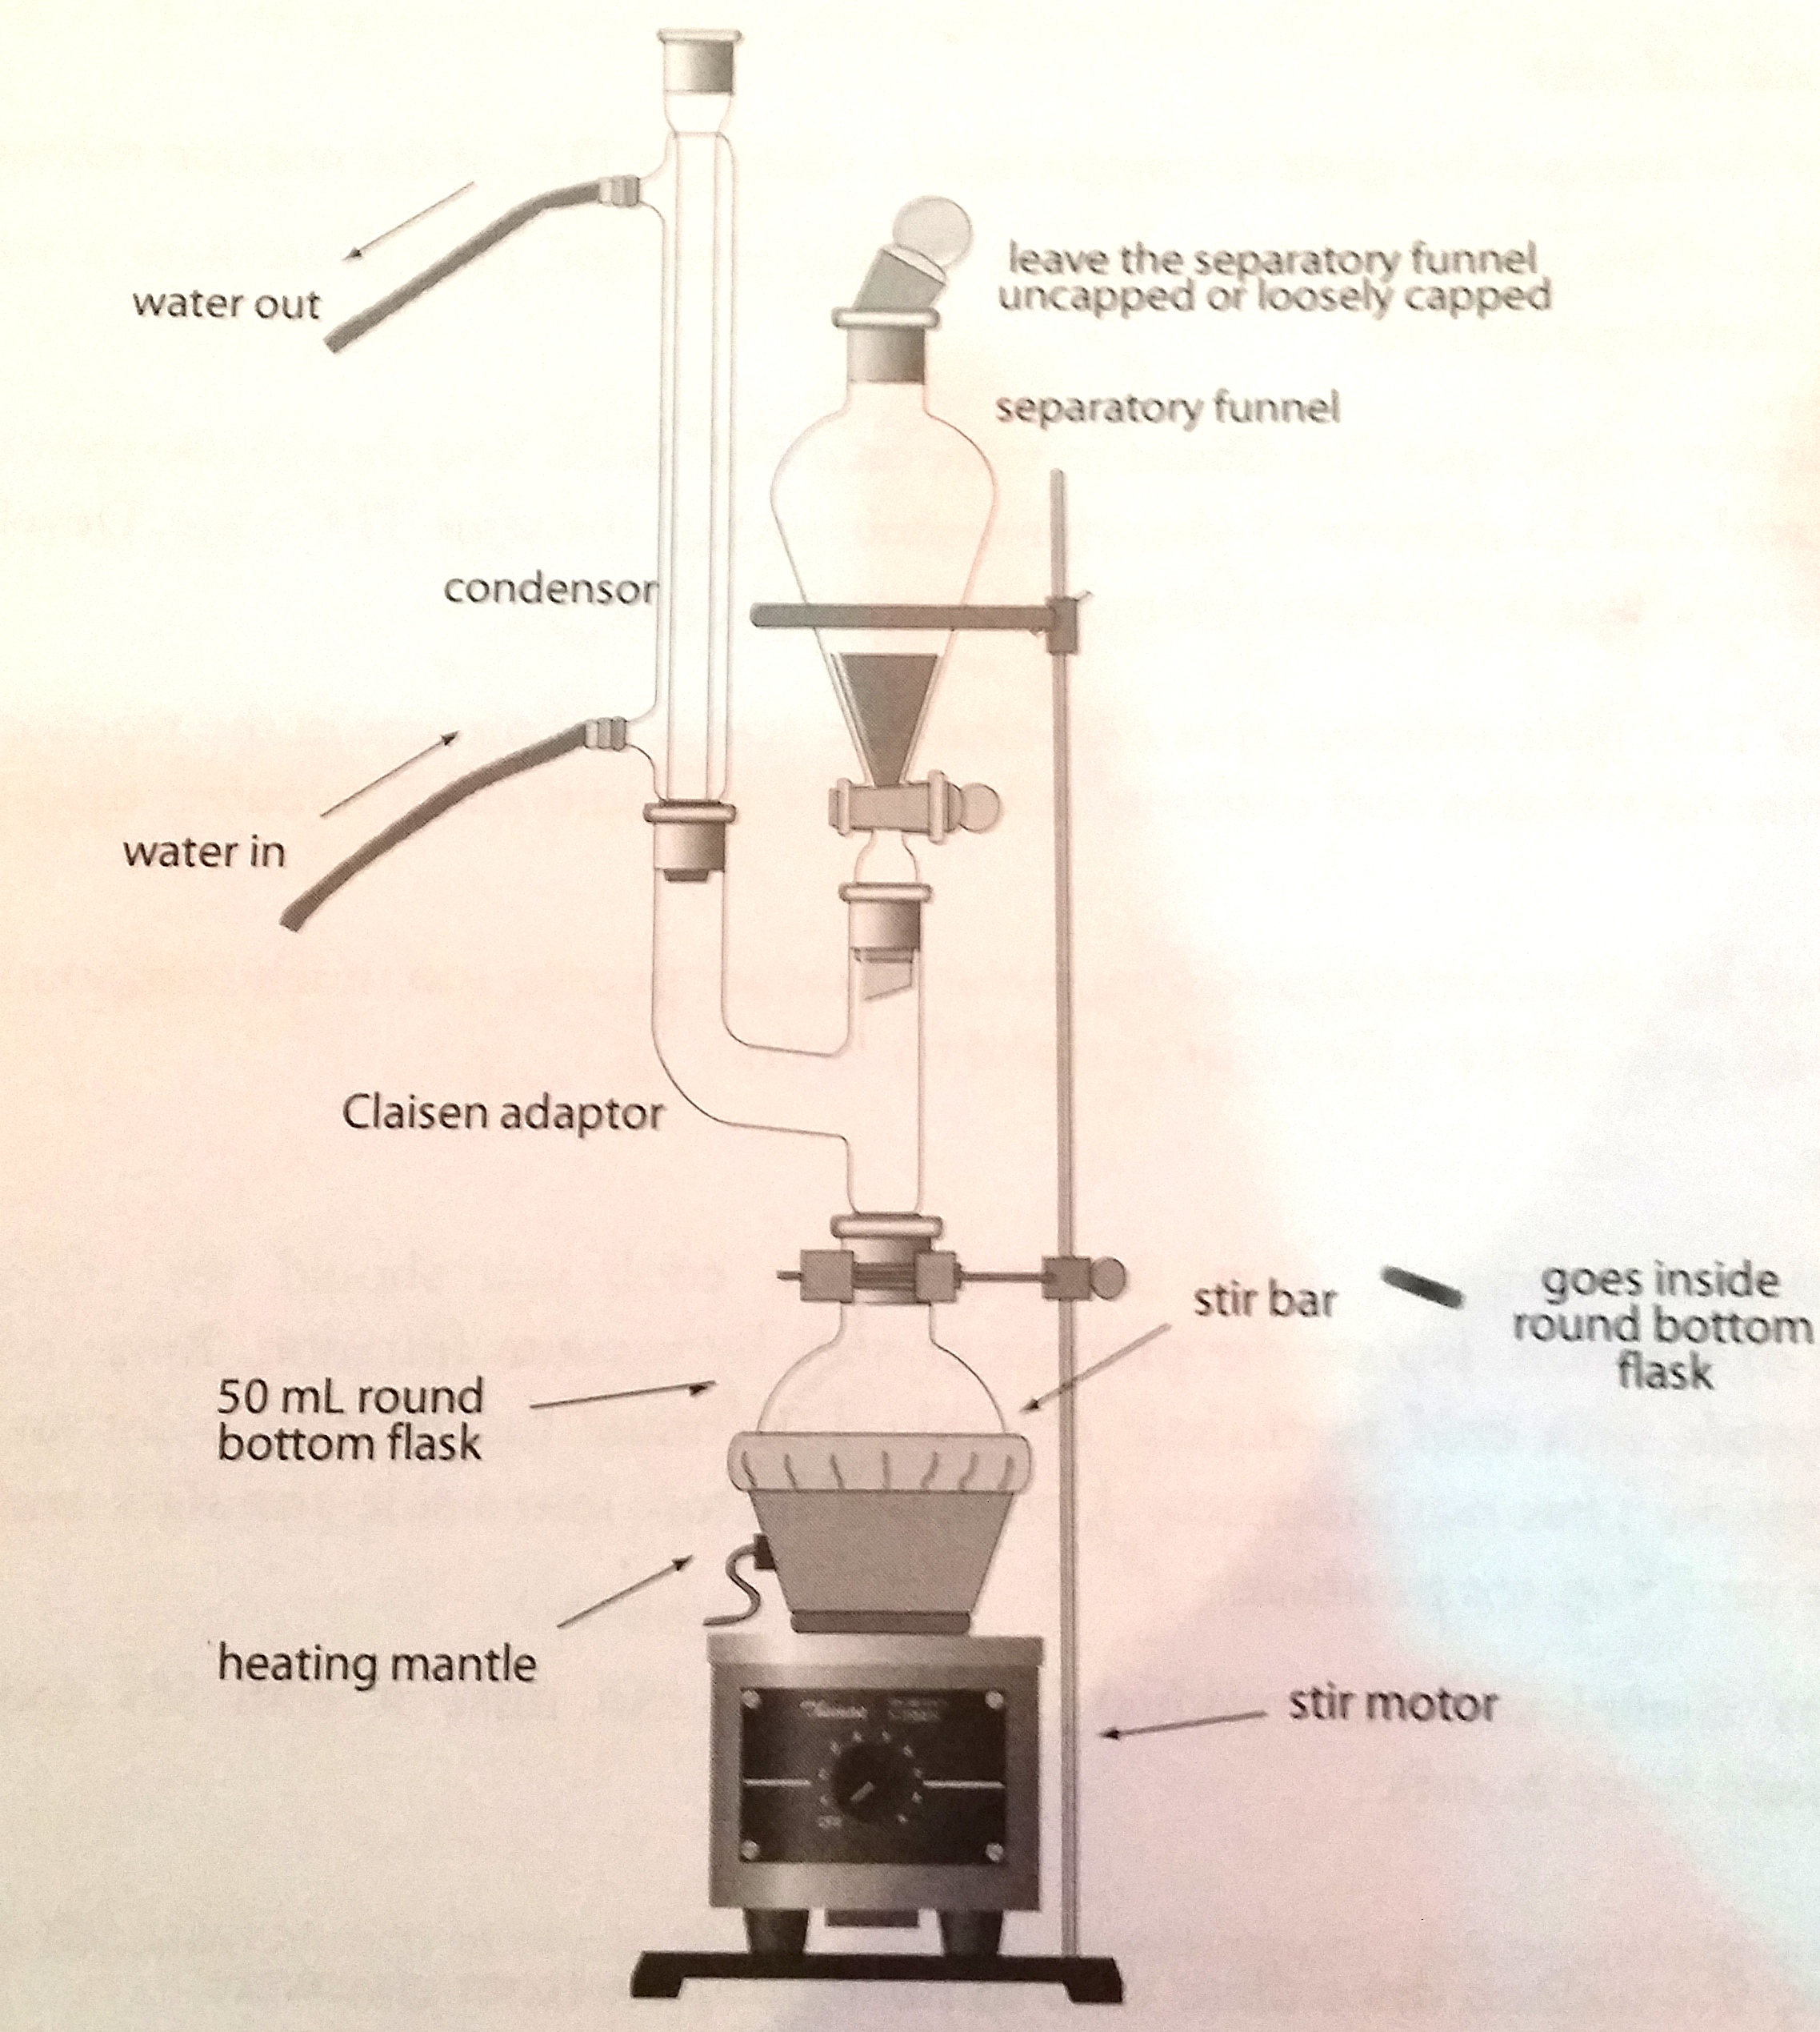
5. Set the Variac to about 45, get the contents of the flask to boiling.
6. Adjust the Variac setting so that the solvent vapors condense about ¼ of the way up the condenser, this is called the “reflux level”.
7. When its refluxed properly, add a few drops of the bromine solution to the flask.
8. When the solution in the reaction flask is nearly colorless, add a portion of bromine solution.
9. Continue this until all the bromine is added.
10. Continue heating the reaction at reflux for an additional 10 minutes.
11. After the reflux process, the thin layer chromatography process is conducted.
12. Determine a TLC solvent system that separates the product from the starting material.
    1. This could be determined when the reaction is refluxing.
13. Run the TLCs of standards: trans-cinnamic acid and 2,3-dibromo-3-phenylpropanoic acid in two different solvent systems to determine a system that separates the two compounds.
14. Remove a drop of reaction mixture with a Pasteur pipet and then dilute it in a vial containing about 1 mL of methylene chloride.
15. With the microcapillary tube, spot this diluted mixture on the TLC plate. Spot both mixtures.
16. If the developed TLC plate indicates that the trans-cinnamic acid is still present in the reaction mixture, should add more bromine solution and continue refluxing for 5 more minutes.
17. Check the TLC plate.
18. After the TLC process is done, it’s the isolation of product.
19. Allow the reaction to cool
20. You should see crystals of the product precipitating out of the solution
21. Isolate the crystals by vacuum filtration.
22. Rinse the reaction flask and the crystals with cold methylene chloride.
23. Determine the melting point and yield of the product.